**Heating and Cooling**

**Assignment**

**Scientific Report**

**MARKING KEY**

**Log Book – Heating and Cooling**

**Aim:**

*What you want to achieve in the experiment?*

________________________________________________________________________________________________________________________________________________________________________________________________

(2 marks: 1 independent variable, 1 dependent)

**Independent variable:** *(change)* __________________________

(1 mark)

**Dependent variable:** *(measure)* ___________________________

(1 mark)

**Controlled variable:** *(same)* ________________________________________________________________________________________________________________________________________________________________________________________________

(Max 3 marks per correct variable)

**Hypothesis:**

If … then...

(2 marks: 1 independent variable, 1 dependent variable)

**Materials and method**:

|  |  |
| --- | --- |
|  |  |
|  |  |

(1 mark)

**Diagram:**

*Draw a scientific diagram of your set up. Remember it should be in pencil, 2D, and label all equipment.*

(3 marks: 0.5 pencil, 0.5 2D, 1 correctly labelled, 1 correct drawings)

**Results:**

*In the space below please construct a table of your results.*

(4 marks: 1 title for table, 1 correct headings, 0.5 all results entered, 0.5 correct columns and rows, 0.5 units, 0.5 pencil/ ruler)

**Graph:**

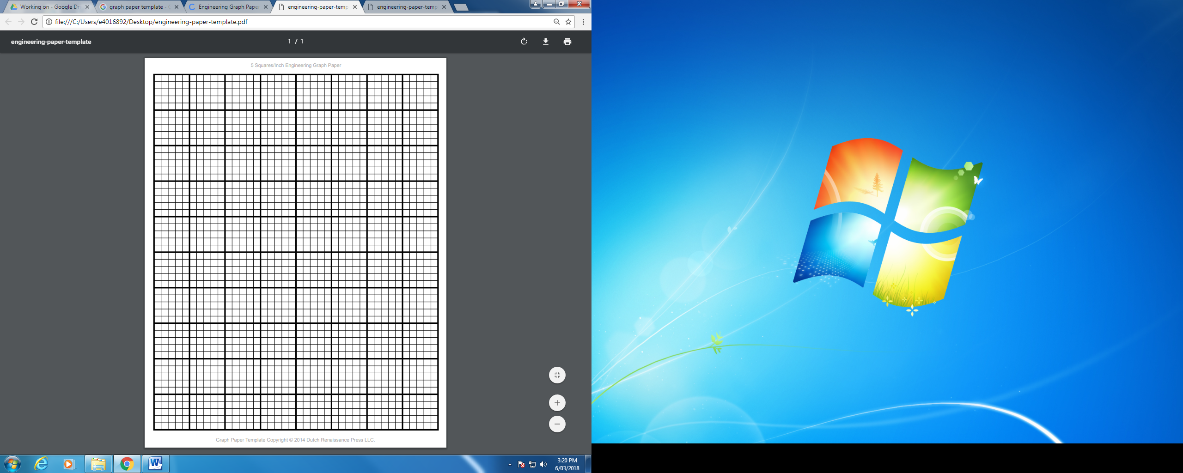 (5 marks: 1 title, 1 correct axis labels, 1 correct units, 0.5 legend, 0.5 pencil/ruler, 1 even scale/ correct plotting)

**Discussion**

*Which drink cooled the fastest?*

________________________________________________________________

(1 mark)

*Which drink cooled the slowest?*

________________________________________________________________

(1 mark)

*Describe the trend or pattern that each graph showed. Was it increasing, decreasing or unpredictable?*

________________________________________________________________

(1 mark)

*Explain why the drinks cooled at different rates.*

________________________________________________________________

________________________________________________________________

________________________________________________________________

________________________________________________________________

(2 marks)

*What improvements could be made to the experiment?*

________________________________________________________________

________________________________________________________________

________________________________________________________________

________________________________________________________________

(2 marks)

**Conclusion**

*Summarise what you discovered at the end of the experiment.*

________________________________________________________________

________________________________________________________________

________________________________________________________________

(1 mark: 0.5 independent, 0.5 dependent)

**Total: /30**

**Comment:** _______________________________________________________________________________________________________________________________________________________________________________________